# Third Year B. Tech (EL & CE)

**Semester: V Subject:** Data Base Management System

**Name: Shreerang Mhatre Class: TY**

**Roll No: 52 Batch: A3**

# Experiment No: 01

**Name of the Experiment**: **SQL- DDL Commands**

**Performed on: 13/09/2023**

**Submitted on: 27/09/2023**

**Problem Statement:**

create, alter, drop, rename, truncate, description(All Basic commands: show: databases, tables, use database, create tables, drop: database, tables, description of table)

Code:

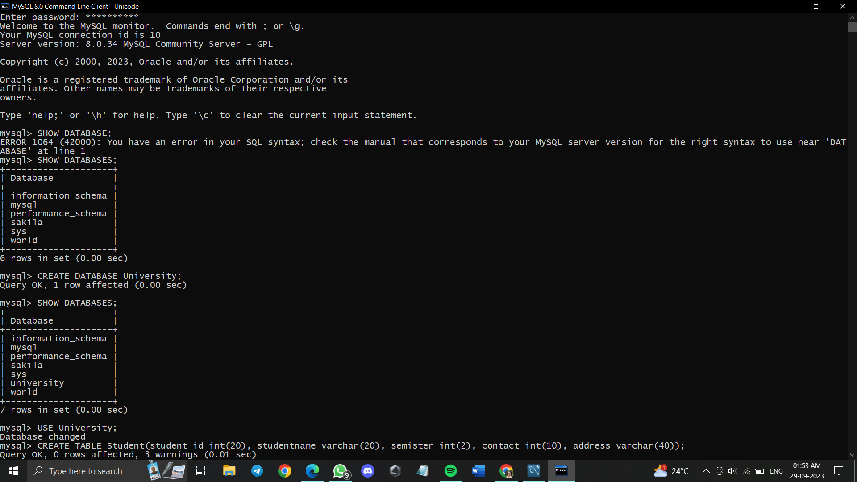

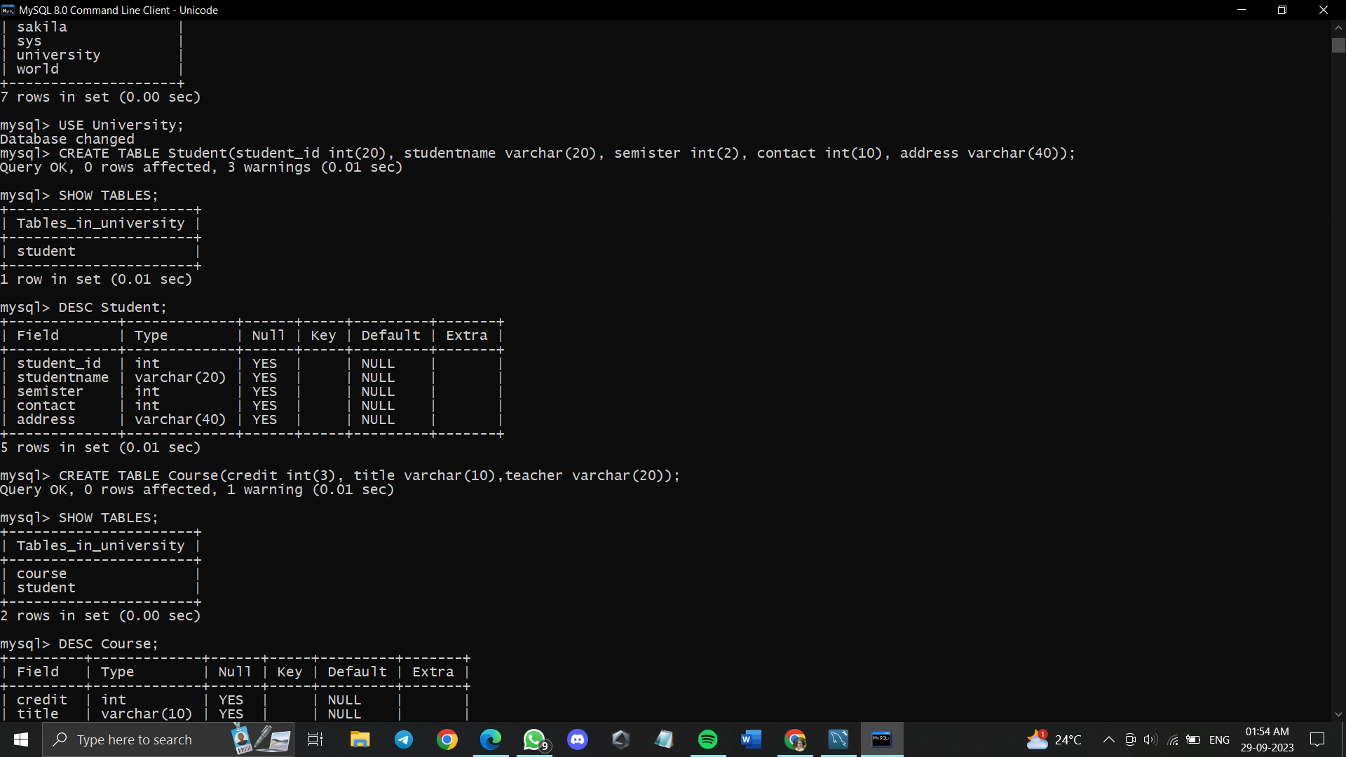

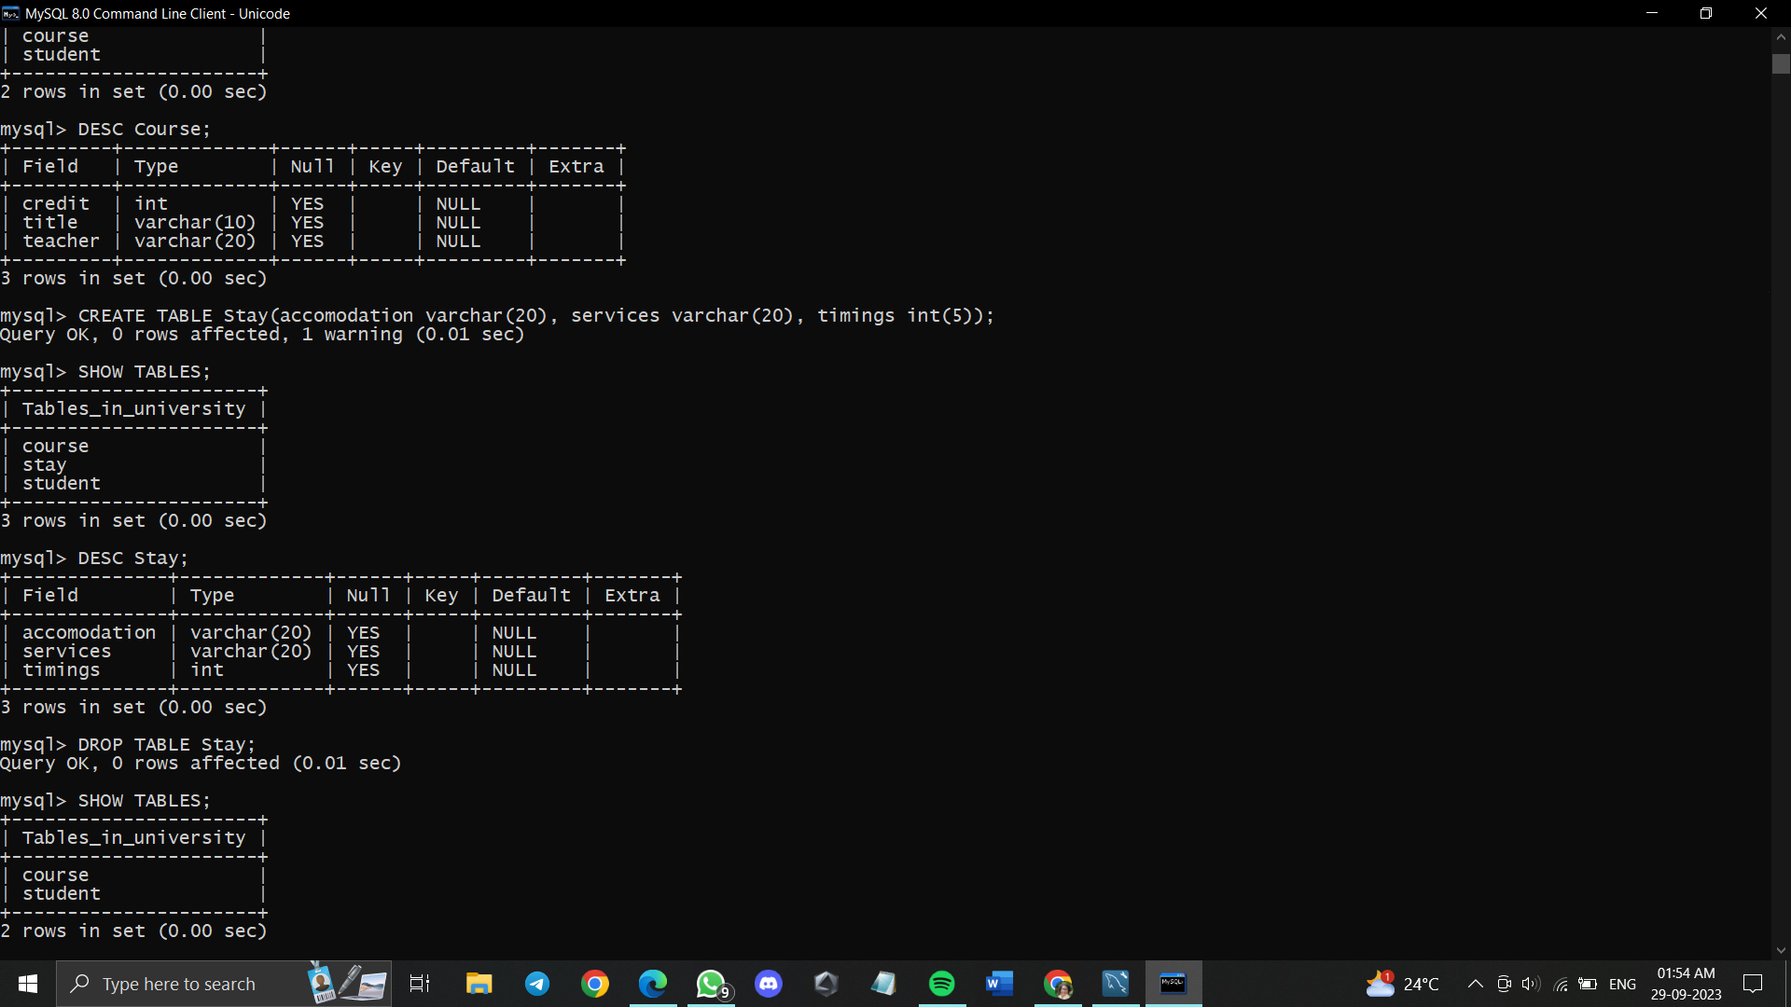

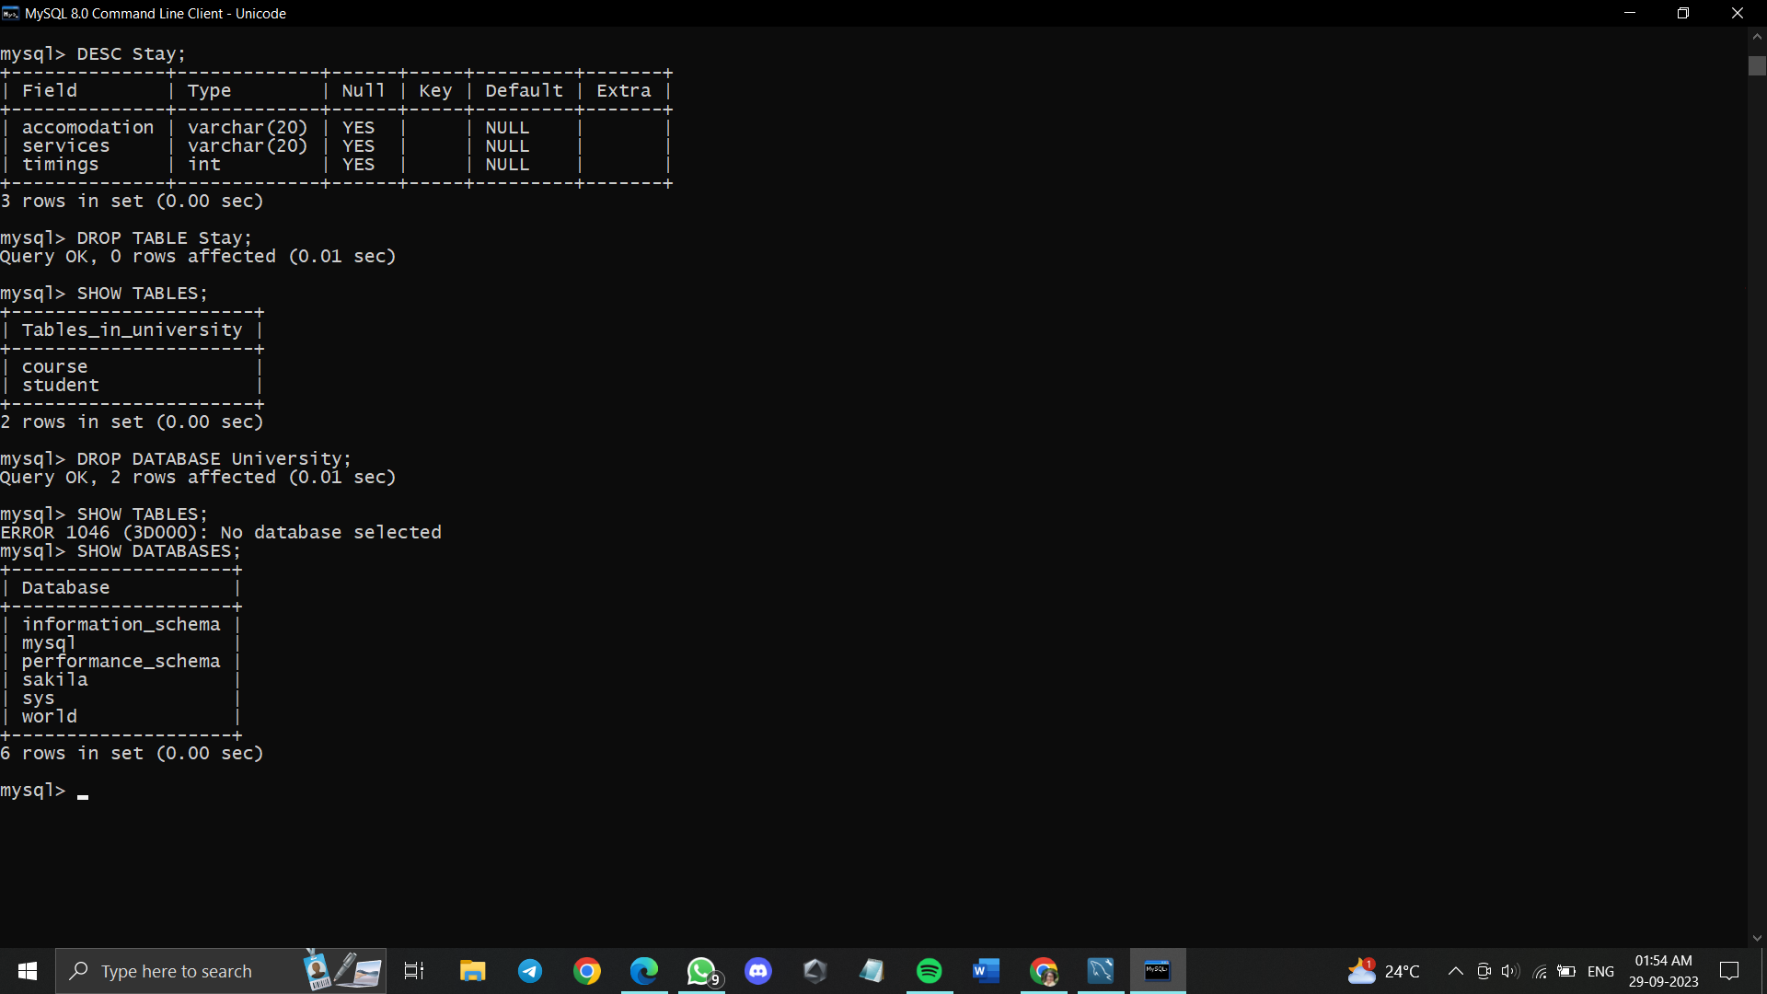

**Post Lab Questions:**

